**Name:=Shreyasi Gidmare PRN=23070521146**

**Practical 3:**

**Part 4:**

**SQL Numeric Functions**

SQL **Numeric Functions** are essential tools for performing **mathematical** and arithmetic operations on numeric data. These functions allow you to manipulate numbers, perform calculations, and **aggregate data** for reporting and analysis purposes.

Note: In this Lab Manual, examples are based on ORACLE SQLPLUS and MYSQL for your support but you are free to use any platform.

# Numeric Functions in SQL*Plus (Oracle) and MySQL

|  |  |
| --- | --- |
| **Function** | **Description** |
| **ABS(n)** | Returns the absolute value of n |
| **ACOS(n)** | Returns the arc cosine (inverse cosine) of n |
| **ASIN(n)** | Returns the arc sine (inverse sine) of n |
| **ATAN(n)** | Returns the arc tangent (inverse tangent) of n |
| **ATN2(y, x) (SQL Server only)** | Returns the angle whose tangent is the quotient  of two arguments (Not available in Oracle/MySQL) |
| **AVG(expression)** | Returns the average of a set of values |
| **CEILING(n)** | Returns the smallest integer greater than or equal to n |

|  |  |
| --- | --- |
| **COUNT(expression)** | Returns the number of rows matching a condition |
| **COS(n)** | Returns the cosine of n (in radians) |
| **COT(n)** | Returns the cotangent of n |
| **DEGREES(n)** | Converts radians to degrees |
| **EXP(n)** | Returns e raised to the power of n |
| **FLOOR(n)** | Returns the largest integer less than or equal to n |
| **LOG(n)** | Returns the natural logarithm (base e) of n |
| **LOG10(n)** | Returns the base-10 logarithm of n |
| **MAX(expression)** | Returns the maximum value in a column |
| **MIN(expression)** | Returns the minimum value in a column |
| **PI()** | Returns the value of π (pi) |
| **POWER(x, y)** | Returns x raised to the power of y |
| **RADIANS(n)** | Converts degrees to radians |
| **RAND()** | Returns a random number between 0 and 1 |
| **ROUND(n, d)** | Rounds n to d decimal places |
| **SIGN(n)** | Returns -1, 0, or 1 depending on the sign of n |
| **SIN(n)** | Returns the sine of n (in radians) |
| **SQRT(n)** | Returns the square root of n |
| **SQUARE(n)** | Returns the square of n (same as POWER(n, 2)) |
| **SUM(expression)** | Returns the sum of a set of values |
| **TAN(n)** | Returns the tangent of n (in radians) |

# 2. Examples in SQL*Plus (Oracle) /skip if you want to use mysql platform

**2.1 Absolute Value (ABS)**

SELECT ABS(-10) FROM dual; -- Result: 10

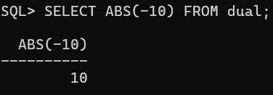

## 2.2 Arc Cosine (ACOS)

SELECT ACOS(0.5) FROM dual; -- Result: 1.04719755 (in

radians)

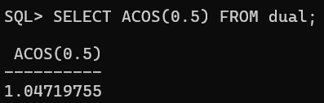

## 2.3 Arc Sine (ASIN)

SELECT ASIN(0.5) FROM dual; -- Result: 0.523598775 (in

radians)

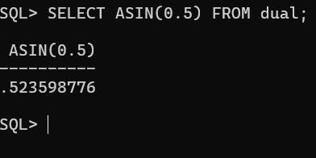

## 2.4 Arc Tangent (ATAN)

SELECT ATAN(1) FROM dual; -- Result: 0.785398163 (in

radians)

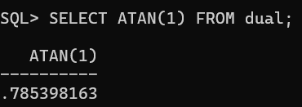

## 2.5 Average (AVG)

SELECT AVG(salary) FROM employees; -- Finds the average

salary

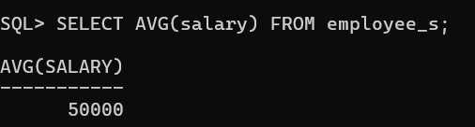

**2.6 Ceiling (CEILING)**

SELECT CEIL(4.2) FROM dual; -- Result: 5

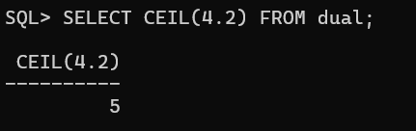

## 2.7 Count (COUNT)

SELECT COUNT(*) FROM employees WHERE department =

'Sales'; -- Counts employees in Sales

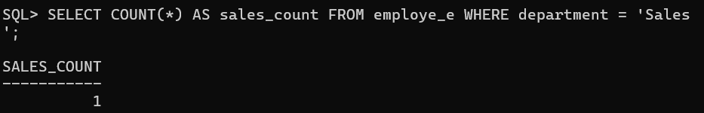

**2.8 Cosine (COS)**

SELECT COS(0) FROM dual; -- Result: 1

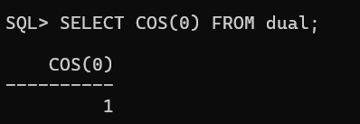

**2.9 Cotangent (COT)**

SELECT 1/TAN(PI()/4) FROM dual; -- Result: 1

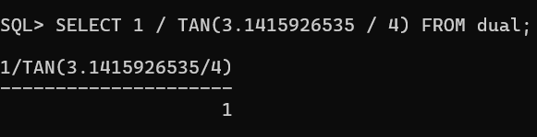

**2.10 Convert Radians to Degrees (DEGREES)**

SELECT DEGREES(PI()/2) FROM dual; -- Result: 90

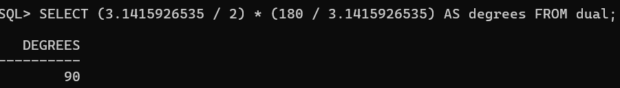

**2.11 Exponential (EXP)**

SELECT EXP(2) FROM dual; -- Result: 7.389056099

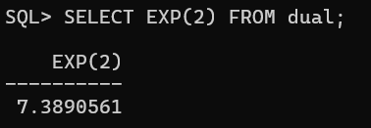

**2.12 Floor (FLOOR)**

SELECT FLOOR(4.8) FROM dual; -- Result: 4

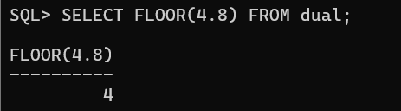

## 2.13 Natural Logarithm (LOG)

SELECT LOG(2.718281828) FROM dual; -- Result: 1 (since

e^1 = e)

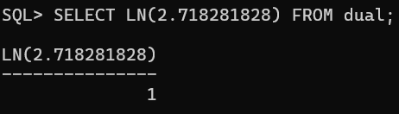

## 2.14 Logarithm Base 10 (LOG10)

SELECT LOG(10, 100) FROM dual; -- Result: 2 (since 10^2 =

100)

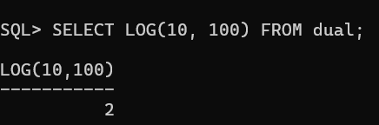

## 2.15 Maximum (MAX)

SELECT MAX(salary) FROM employees; -- Finds the highest

salary

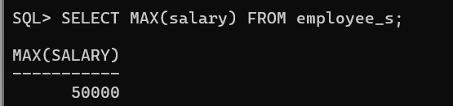

## 2.16 Minimum (MIN)

SELECT MIN(salary) FROM employees; -- Finds the lowest

salary

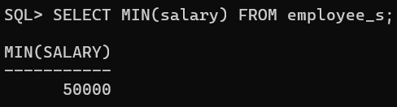

**2.17 Pi (PI)**

SELECT ACOS(-1) FROM dual; -- Result: 3.14159265

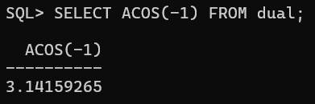

**2.18 Power (POWER)**

SELECT POWER(3, 2) FROM dual; -- Result: 9

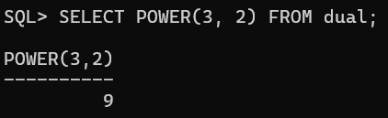

**2.19 Convert Degrees to Radians (RADIANS)**

SELECT RADIANS(180) FROM dual; -- Result: 3.14159265

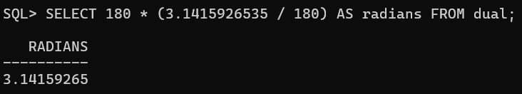

## 2.20 Random Number (RAND)

SELECT DBMS_RANDOM.VALUE FROM dual; -- Returns a random

number between 0 and 1

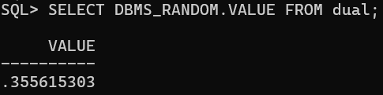

**2.21 Round Number (ROUND)**

SELECT ROUND(3.14159265, 2) FROM dual; -- Result: 3.14

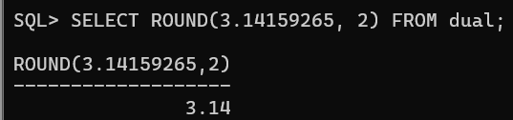

## 2.22 Sign of Number (SIGN)

SELECT SIGN(-10) FROM dual; -- Result: -1

SELECT SIGN(0) FROM dual; -- Result: 0

SELECT SIGN(10) FROM dual; -- Result: 1

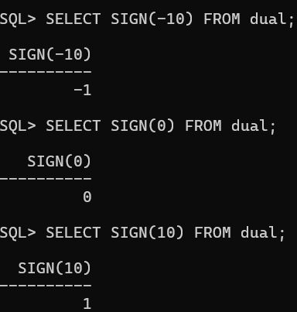

**2.23 Sine (SIN)**

SELECT SIN(PI()/2) FROM dual; -- Result: 1

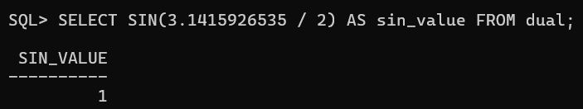

**2.24 Square Root (SQRT)**

SELECT SQRT(16) FROM dual; -- Result: 4

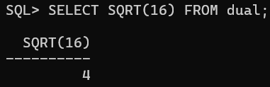

**2.25 Square (SQUARE)**

SELECT POWER(4, 2) FROM dual; -- Result: 16

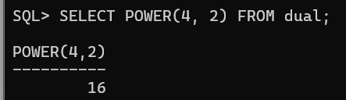

**2.26 Sum (SUM)**

SELECT SUM(salary) FROM employees; -- Sum of all salaries

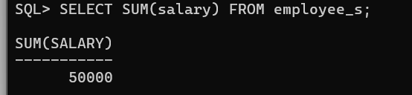

## 2.27 Tangent (TAN)

SELECT TAN(PI()/4) FROM dual; -- Result: 1

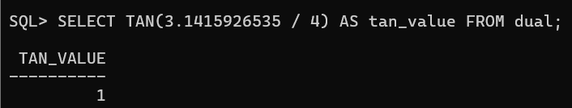

# 3. Examples in MySQL //SKIP IF DONE WITH ORACLE SQLPLUS

🔹 The MySQL syntax is almost the same as Oracle, except for some functions.

SELECT ABS(-10); -- 10

SELECT ACOS(0.5); -- 1.04719755

SELECT ASIN(0.5); -- 0.523598775

SELECT ATAN(1); -- 0.785398163

SELECT AVG(salary) FROM employees;

SELECT CEIL(4.2); -- 5

SELECT COUNT(*) FROM employees WHERE department =

'Sales';

SELECT COS(0); -- 1

SELECT COT(1); -- 0.6420926159

SELECT DEGREES(PI()/2); -- 90

SELECT EXP(2); -- 7.389056099

SELECT FLOOR(4.8); -- 4

SELECT LOG(2.718281828); -- 1

SELECT LOG10(100); -- 2

SELECT MAX(salary) FROM employees;

SELECT MIN(salary) FROM employees;

SELECT PI(); -- 3.1415926535

SELECT POWER(3, 2); -- 9

SELECT RADIANS(180); -- 3.1415926535

SELECT RAND(); -- Random number

SELECT ROUND(3.14159265, 2); -- 3.14

SELECT SIGN(-10); -- -1

SELECT SIN(PI()/2); -- 1

SELECT SQRT(16); -- 4

SELECT SUM(salary) FROM employees;

SELECT TAN(PI()/4); -- 1

# Advanced SQL Numeric Function Use Cases (Oracle & MySQL)

Fllowing are **complex queries** using **numeric functions** in **real-world applications** for **financial analysis, scientific calculations, data analytics, and system performance monitoring**.

## 1 ⃣ Financial Analytics: Compound Interest Calculation

**Use Case:** Calculate compound interest for a bank’s customer accounts.

SELECT account_id, principal, interest_rate, years,

ROUND(principal * POWER((1 + interest_rate / 100),

years), 2) AS future_value

FROM savings_accounts;

**Formula Used:**

FV=P×(1+r/n)(nt)FV = P \times (1 + r/n)^{(nt)}FV=P×(1+r/n)(nt) Where:

principal: Initial deposit

* interest_rate: Annual interest rate
* years: Time period
* POWER() function computes exponentiation **Result Example:**

|  |  |  |  |  |
| --- | --- | --- | --- | --- |
| **account_id** | **principal** | **interest_rate** | **years** | **future_value** |
| 101 | 1000 | 5 | 10 | 1628.89 |

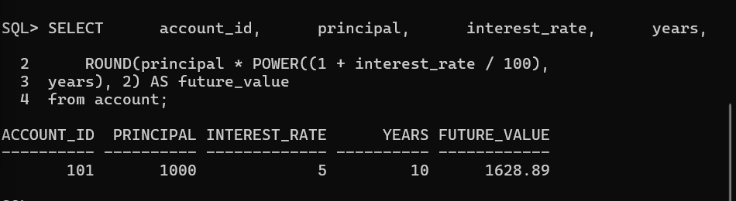

## 2 ⃣ Customer Segmentation: Standard Deviation of Purchases

**Use Case:** Find **customer spending variability** to create better promotions.

SELECT customer_id,

ROUND(AVG(purchase_amount), 2) AS avg_spend,

ROUND(STDDEV(purchase_amount), 2) AS

spending_variability

FROM orders

GROUP BY customer_id

HAVING COUNT(*) > 5; -- Filter frequent customers

**Key Insights:**

● Uses STDDEV() to measure customer spending consistency.

Filters for customers with at least **5 purchases** (HAVING COUNT(*) >

5).

**Result Example:**

|  |  |  |
| --- | --- | --- |
| **customer_id** | **avg_spend** | **spending_variability** |
| 201 | 250.00 | 50.25 |
| 305 | 500.00 | 120.75 |

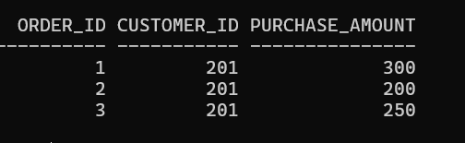

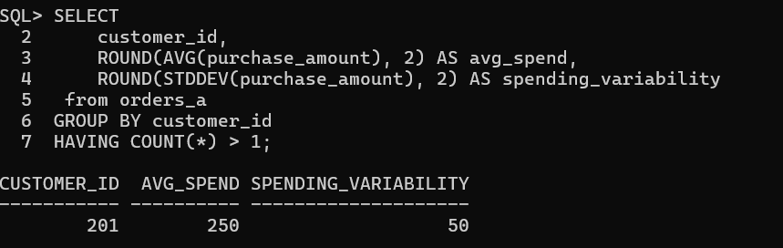

## 3 ⃣ Real-Time Performance Monitoring: CPU Load Analysis

**Use Case:** Compute **CPU load trend** for a cloud server system.

SELECT server_id,

ROUND(AVG(cpu_usage), 2) AS avg_cpu,

ROUND(MAX(cpu_usage), 2) AS max_cpu,

ROUND(MIN(cpu_usage), 2) AS min_cpu,

ROUND(SQRT(POWER(MAX(cpu_usage) - MIN(cpu_usage),

2)), 2) AS load_variance FROM server_logs

WHERE log_date >= SYSDATE - INTERVAL '7' DAY -- Last 7

days

GROUP BY server_id;

**Key Metrics:**

AVG() to measure **average CPU usage**.

* MAX() & MIN() for **peak & lowest usage**.
* SQRT(POWER()) to calculate variance in load.

**Result Example:**

|  |  |  |  |  |
| --- | --- | --- | --- | --- |
| **server_id** | **avg_cpu** | **max_cpu** | **min_cpu** | **load_variance** |
| A123 | 65.25 | 92.75 | 45.50 | 47.25 |
| B456 | 40.10 | 75.00 | 20.20 | 54.80 |
|  |  |  |  |  |

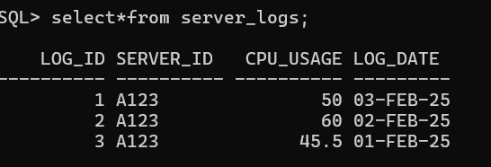

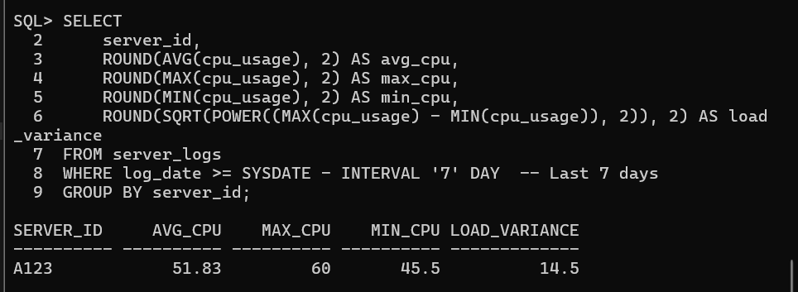

## 4 ⃣ Fraud Detection: Identifying Abnormal Transactions

**Use Case:** Detect transactions that are significantly **higher** than the usual customer behavior.

SELECT transaction_id, customer_id, amount,

(SELECT AVG(amount) FROM transactions WHERE customer_id = t.customer_id) AS avg_amount,

(SELECT STDDEV(amount) FROM transactions WHERE customer_id = t.customer_id) AS stddev_amount

FROM transactions t

WHERE amount > (SELECT AVG(amount) + 2 * STDDEV(amount)

FROM transactions WHERE customer_id = t.customer_id);

**Logic:**

**Outlier transactions** are those **greater than 2 standard deviations** from the average.

● Uses AVG() and STDDEV() **per customer** to personalize fraud detection.

**Result Example:**

|  |  |  |  |  |
| --- | --- | --- | --- | --- |
| **transaction_i d** | **customer_i d** | **amoun**  **t** | **avg_amou**  **nt** | **stddev_amou**  **nt** |
| 90872 | 201 | 12000 | 3000 | 4500 |

🔹 **If a customer usually spends $3,000 ± $4,500, a $12,000 transaction is flagged as suspicious.**

## 5 ⃣ Logistics: Estimating Delivery Time Based on Distance

**Use Case:** Predict **delivery time (in hours)** for orders based on **distance and speed factors**.

SELECT order_id, distance_km,

ROUND(distance_km / avg_speed, 2) AS

estimated_delivery_time

FROM (

SELECT order_id, distance_km,

CASE

WHEN distance_km < 50 THEN 60 -- Urban: 60

km/h

WHEN distance_km BETWEEN 50 AND 200 THEN 80

-- Suburban: 80 km/h

ELSE 100 -- Highway: 100 km/h

END AS avg_speed

FROM orders

);

**Business Insight:**

● Uses **speed categories** (CASE) to calculate **realistic delivery estimates**. ● Uses ROUND() to **format** the estimated time.

**Result Example:**

|  |  |  |
| --- | --- | --- |
| **order_id** | **distance_km** | **estimated_delivery_time (hrs)** |
| 101 | 120 | 1.50 |
| 202 | 20 | 0.33 |

**6** ⃣ **Astronomy/Physics: Calculating Earthquake Magnitude**

# (Logarithmic Formula)

**Use Case:** Compute earthquake **Richter magnitude** based on **seismic wave amplitude**.

SELECT earthquake_id, station_id, amplitude,

ROUND(LOG10(amplitude) + 3, 2) AS magnitude

FROM seismic_readings;

**Richter Scale Formula:**

M=log10(A)+3 M = \log_{10} (A) + 3M=log10 (A)+3

● Uses LOG10() to calculate **magnitude from amplitude**.

**Result Example:**

|  |  |  |  |
| --- | --- | --- | --- |
| **earthquake_id** | **station_id** | **amplitude** | **magnitude** |
| EQ001 | ST1001 | 5000 | 6.70 |

## 7 ⃣ E-Commerce: Personalized Discount Calculation

**Use Case:** Apply dynamic **discount rates** based on **spending history**.

SELECT customer_id, total_spent,

CASE

WHEN total_spent > 10000 THEN ROUND(total_spent *

0.15, 2) WHEN total_spent BETWEEN 5000 AND 10000 THEN

ROUND(total_spent * 0.10, 2)

ELSE ROUND(total_spent * 0.05, 2)

END AS discount

FROM (

SELECT customer_id, SUM(order_value) AS total_spent

FROM orders GROUP BY customer_id

);

**Discount Strategy:**

* **15% off** for VIP customers (> $10,000)
* **10% off** for mid-level ($5,000 - $10,000)
* **5% off** for casual shoppers (< $5,000) **Result Example:**

|  |  |  |
| --- | --- | --- |
| **customer_id** | **total_spent** | **discount** |
| 101 | 12000 | 1800 |
| 202 | 7500 | 750 |